LANGUAGE DEVELOPMENT ONE
MIDDLE CLASS TERM ONE 2026

LEARNING AREA 2 INTERACTING WITH, EXPLORING KNOWING AND USING MY ENVIRONMENT (LANGUAGE DEVELOPMENT I) TERM I
WEEK 2
- Exploring and knowing my immediate Environment
- I can report about important places in the environment. Suggested developmental activities
- Drawing important places in the environment.
- Completing and coloring the pictures of the important places
- Reciting rhymes about the important places
- Role-playing doctor, nurse, shopkeeper, priest, and teacher.
- Naming the people who are found in the important places.
- Matching places with the people who work there.

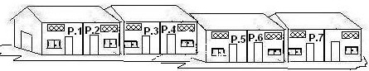Important places

 |  | Activity:Read and draw.
 |  |  | Mosque |  | School |  |  | Hospital
 |  | Name the picture
 |  | 
 |  | Mosque |  |  |  | School |  |  | Hospital
Shade me well please
WEEK 3 AND 4
People we found in the important places
 |  |  | 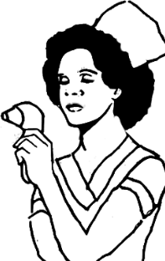 |  |  |  |  |  |  | 
 |  |  | Nurse | Doctor |  |  | Teacher |  |  | Police man
WEEK 5-6
Knowing how to keep and take care of environment I can keep my environment clean.

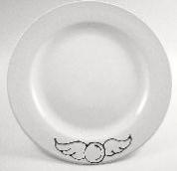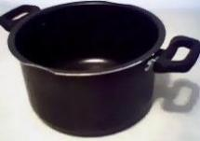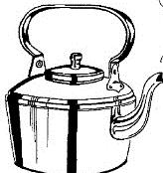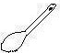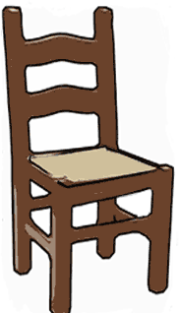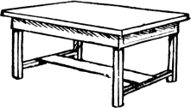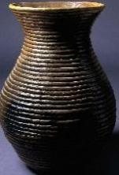Things at home.

Activity
Read and draw things found at home

Plate | Cup
Broom | Table
Television | Mug

Name the pictures.
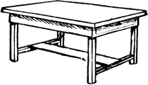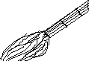
Match the same words
Television radio
Radio bed
Bed television
WEEK 7 & 8
- I can keep my environment clean.
Things found in class

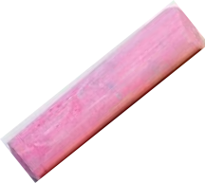
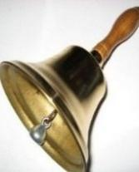

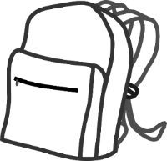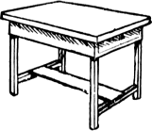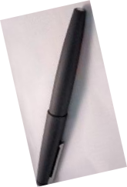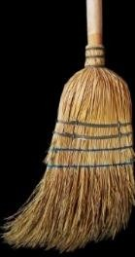

Activity: Name the things found in class

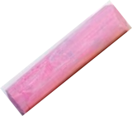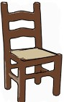

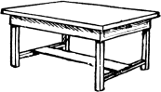

Read and write
Bell Book Box Bag Tin Chalk
Read and draw
Bell
Book
Box
Bag
Tin
Chalk
Chalk | Chair | Book | Chalkboad | Tin
Luler | Table | Bench | Ball | pencil

